**MEDICAL INVENTORY OPTIMIZATION**

**(By sadnya kolhe)**

THE PREPROCESSING OF DATA SET USING SQL (MYSQL)

**#To know the number of rows and columns in the data set**

**Query:-**

#count number of rows

SELECT count(*) as Row_count FROM abc.sadnya;

#count number of columns

SELECT count(*) AS column_count

FROM information_schema.columns

WHERE table_name = 'sadnya';

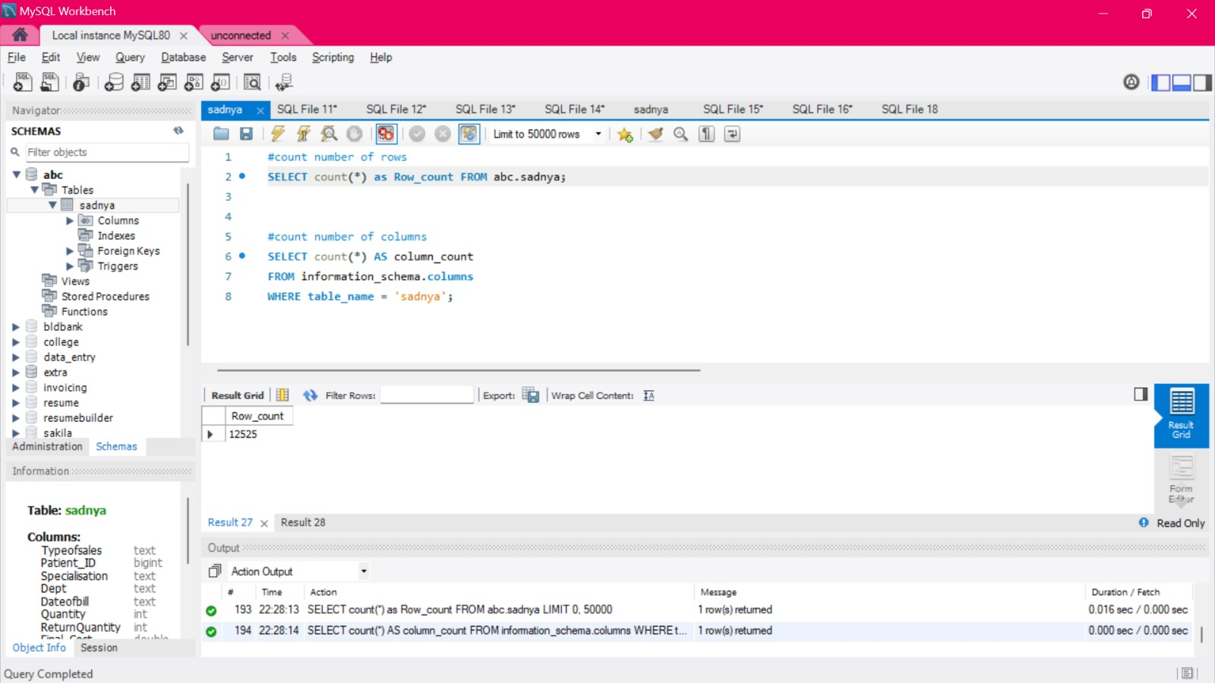

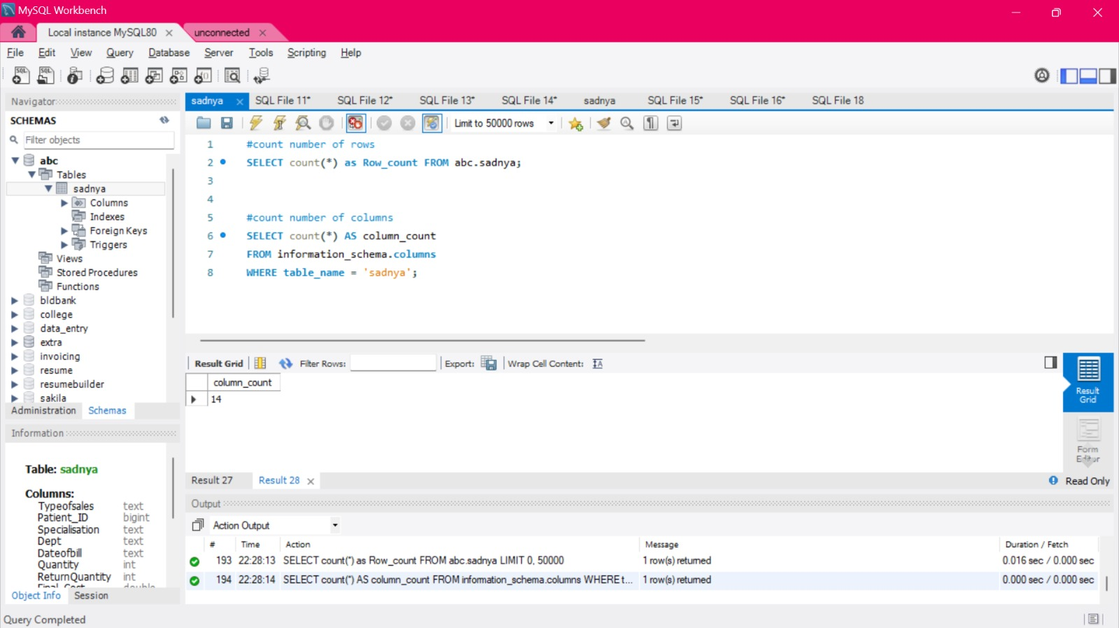

**#To know the data type of of all parameter in data set**

**Query:-**

**#data types**

SELECT COLUMN_NAME, DATA_TYPE FROM INFORMATION_SCHEMA.COLUMNS

WHERE TABLE_SCHEMA = 'abc' AND TABLE_NAME = 'sadnya'

|  |  |
| --- | --- |
| **COLUMN_NAME** | **DATA_TYPE** |
| Type_of_sale | **Text** |
| Patient _ID | **Bigint** |
| Specilisation | **Text** |
| Dept | **Text** |
| Date_of_bill | **Text** |
| Quantity | **Int** |
| Return_Quantity | **Int** |
| Final_cost | **Double** |
| Final_sale | **double** |

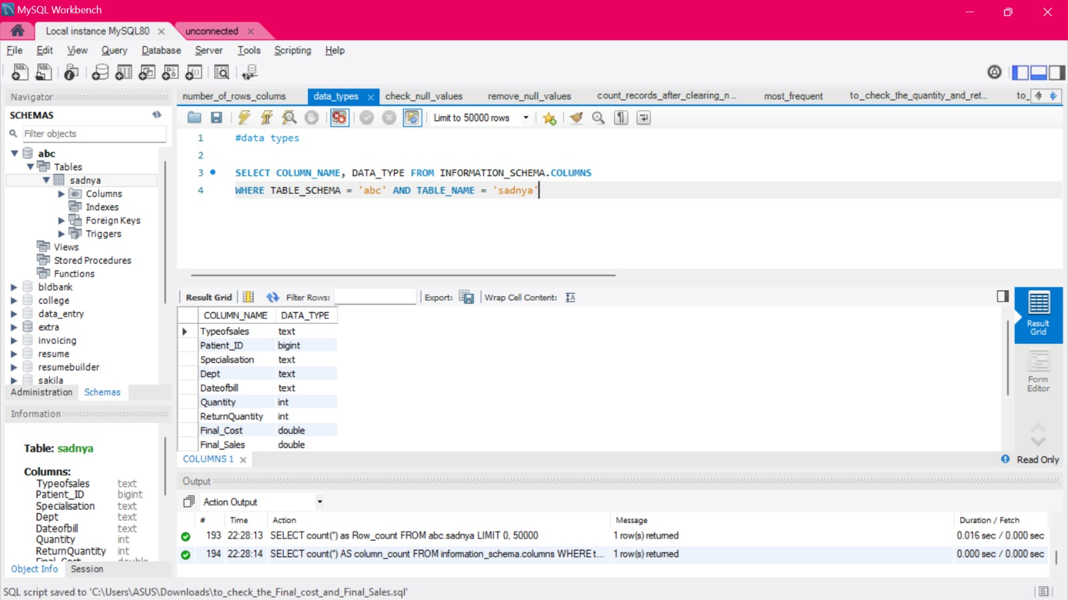

**# To check the null values in the whole dataset**

**Query:-**

#Check Null values

select * from sadnya where SubCat =''or Formulation ='' or DrugName='' or SubCat1 ='';

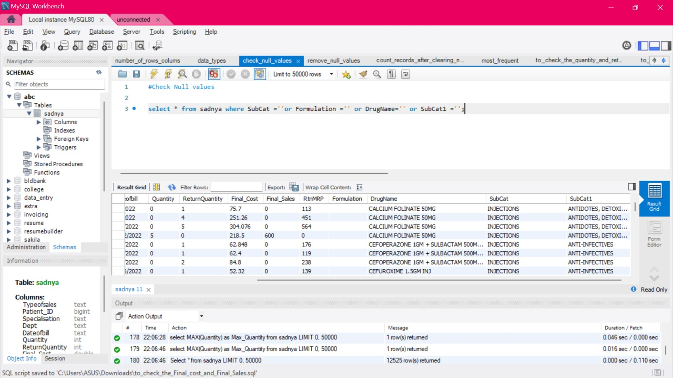

**# To remove or delete the null values in dataset**

**Query:-**

#Remove Null values

Delete from sadnya where SubCat1 ='';

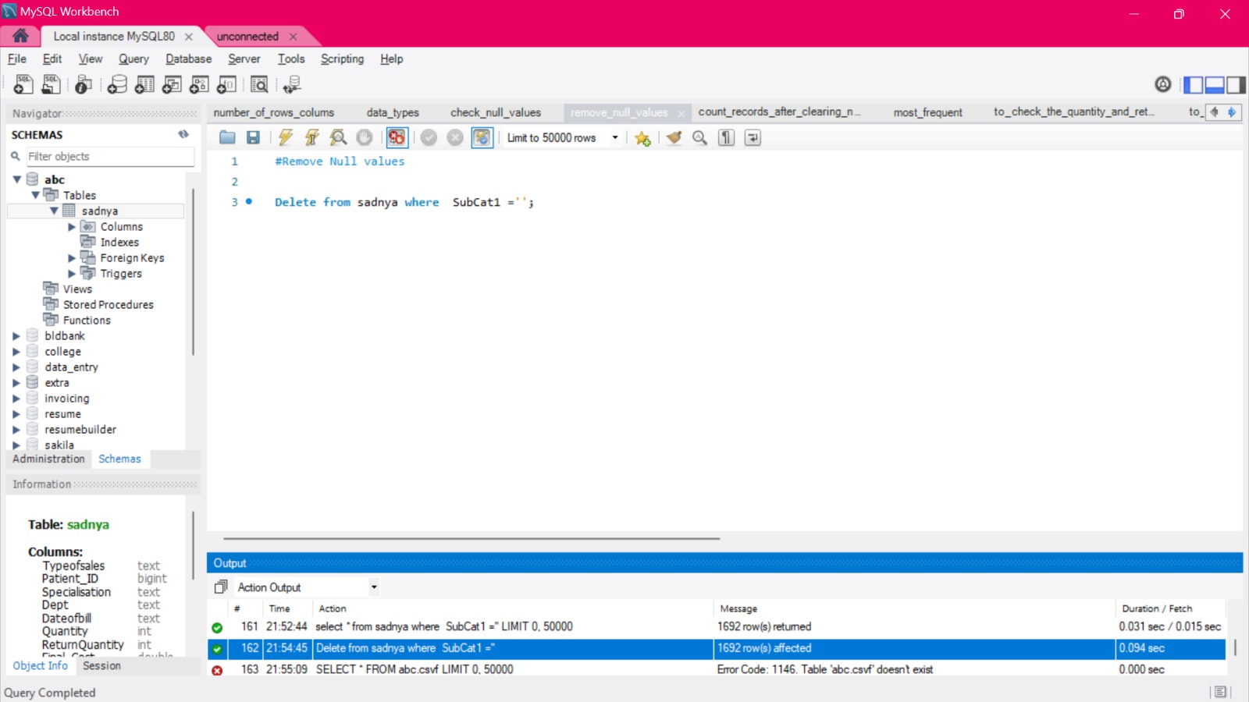

**# After clearing the null values to check the total entries**

**Query:-**

# After clearing the null values check the total entries

Select count(*) as New_Reords from sadnya;

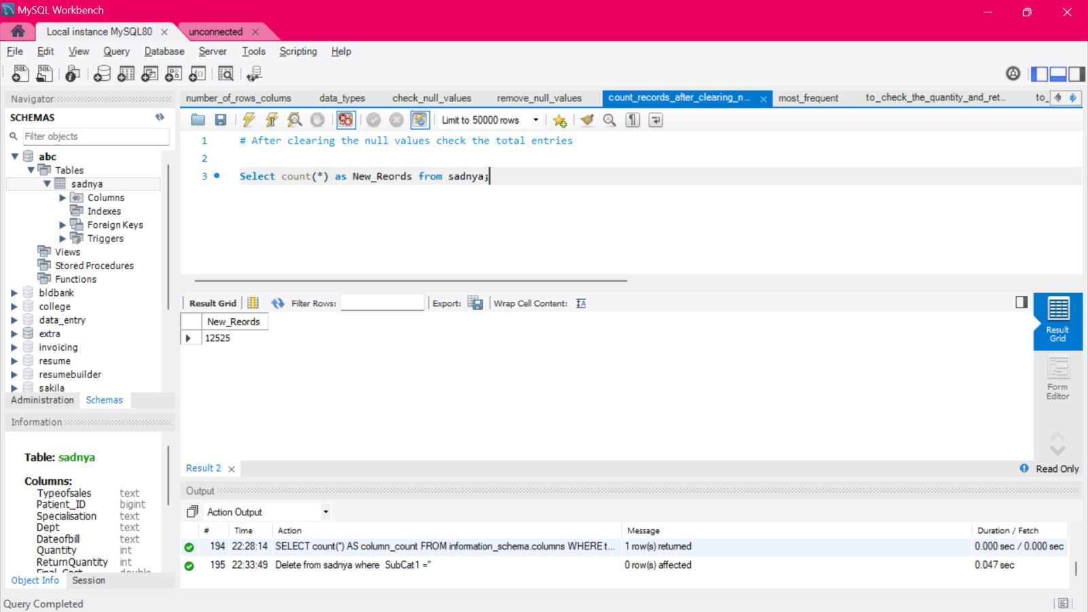

**#Finding the most frequent value in specialization, sub cat 1, sub cat**

**Query:-**

# finiding the most frequent value in specialization, subcat and subCat1

SELECT Specialisation , Count(*) as Frequency FROM sadnya group by Specialisation order by Frequency DESC limit 3 ;

SELECT SubCat , Count(*) as Frequency FROM sadnya group by Specialisation order by Frequency DESC limit 3 ;

SELECT Subcat1 , Count(*) as Frequency FROM sadnya group by Specialisation order by Frequency DESC limit 3;

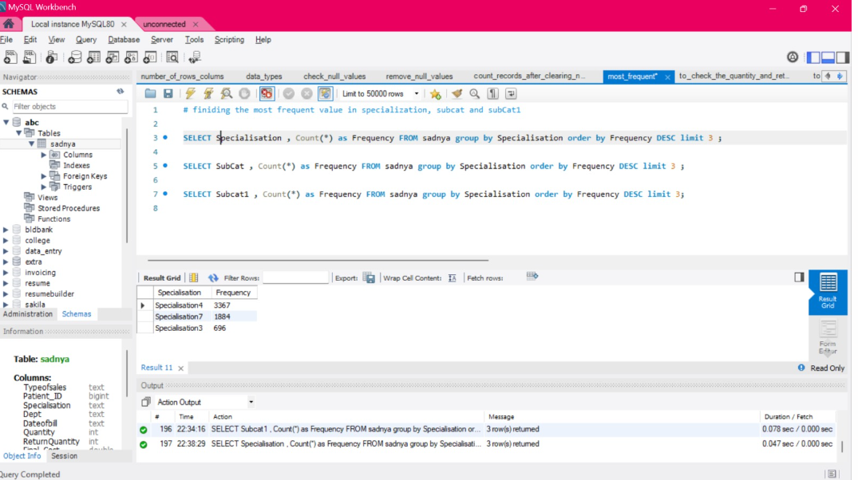

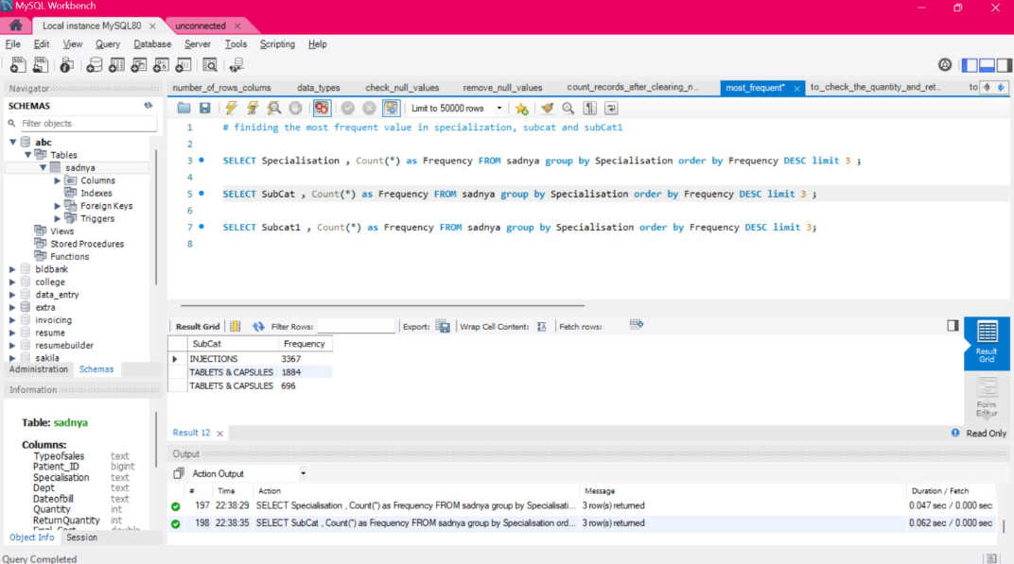

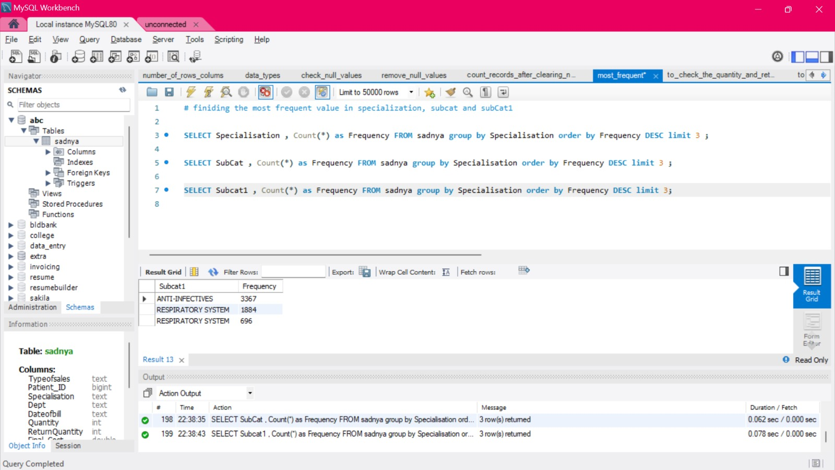

**#To check the avg ,min max, var ,std of Quantity and Return Quantity**

**Query:-**

# to check the quantity and return quantity

select AVG(Quantity) as Avg_Quantity ,

MAX(Quantity) as Max_Quantity ,

MIN(Quantity) as Min_Quantity ,

STDDEV(Quantity) as StdDev_Quantity ,

variance(Quantity) as Var_Qunatity

from sadnya ;

select AVG(ReturnQuantity) as Avg_Ret_Quantity ,

MAX(ReturnQuantity) as Max_Ret_Quantity ,

MIN(ReturnQuantity) as Min_Ret_Quantity ,

STDDEV(ReturnQuantity) as StdDev_Ret_Quantity ,

variance(ReturnQuantity) as Var_Ret_Qunatity

from sadnya ;

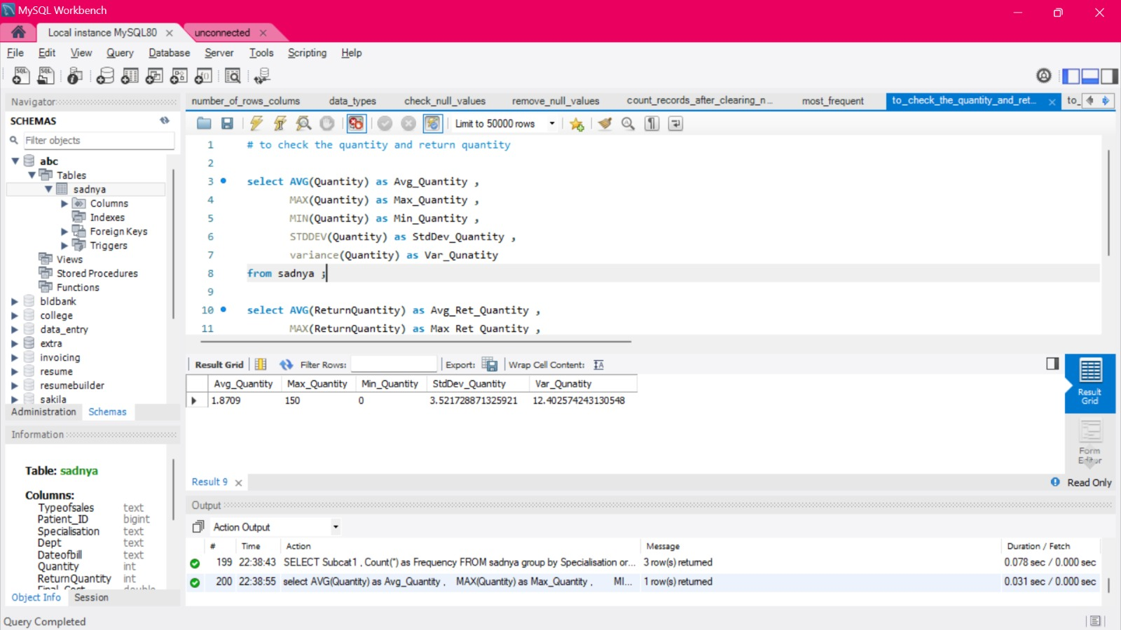

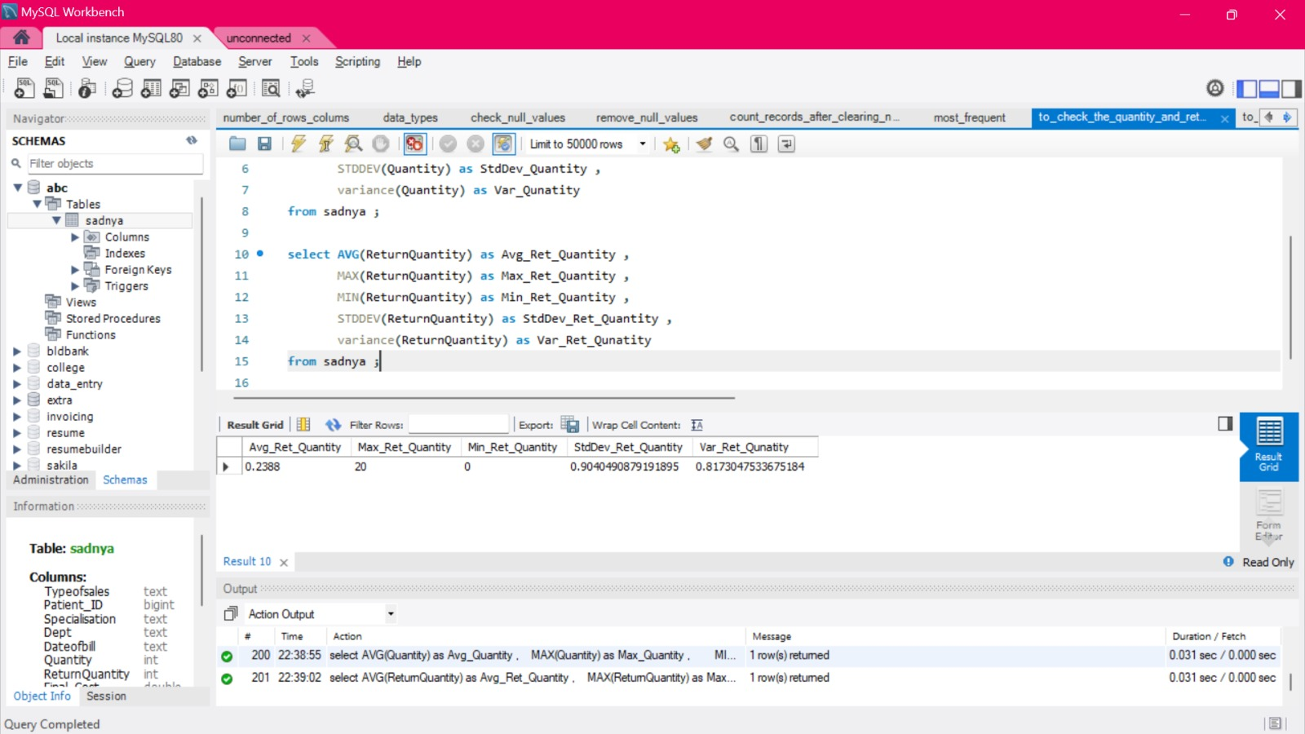

**#To check the avg , min, max, var ,std of final cost and final sale**

**Query:-**

# to check the Final_Cost and Final_Sales

select AVG(Final_Cost) as Avg_Final_Cost ,

MAX(Final_Cost) as Max_Final_Cost ,

MIN(Final_Cost) as Min_Final_Cost ,

STDDEV(Final_Cost) as StdDev_Final_Cost ,

variance(Final_Cost) as Var_Final_Cost

from sadnya ;

select AVG(Final_Sales) as Avg_Final_Sales ,

MAX(Final_Sales) as Max_Final_Sales ,

MIN(Final_Sales) as Min_Final_Sales ,

STDDEV(Final_Sales) as StdDev_Final_Sales ,

variance(Final_Sales) as Var_Final_Sales

from sadnya ;

